# WD 5 Assessment runs for Turbot IV

The SAM assessment model ({Nielsen, 2014 #454}) has been used to test different data and parameter configurations for the Turbot assessment. Data sources and the inter-benchmark modifications are described in WD1-4.

Procedurally we start with an assessment close to the one WGNSSK 2017 left off with, including data back till 1975 and three surveys (SNS, BTS-ISIS and NL LpUE). We configured the SAM assessment such that parameters were given freedom where needed and were restrained when AIC criteria indicated a more restrictive model was preferred. The configuration is a first attempt to ensure following scenarios will run smoothly and once a final data specification is agreed upon, model parameterisation needs to be executed again.

In total, 27 sensitivities are run, a table with run name, ID, description and output file is given below. The ‘name’ can be used to search for the R-script used to run the sensitivity at <https://github.com/ices-eg/wg_IBPTur.27.4/tree/master/assessment%20runs/Trial_runs_2017>. The datafile refers to the output of the run and contains the assessment objects, settings etc.

There are runs where the catch-at-age matrix is truncated or leaving out specific data from either the UK or Denmark. There are runs in which surveys are added (e.g. IBTS, BTS-delta-gam method etc) and there are runs in which the plusgroup of either the catch-at-age or survey-at-age data is decreased. There are no further assessment model configuration (i.e. parameter binding) sensitivities executed and these will follow once the input data selection has been agreed upon.

|  |  |  |  |
| --- | --- | --- | --- |
| name | Run ID | description | datafile |
| base | 1 | WGNSSK base run | base_assessmentOut |
| trim89 | 2 | Start CaA in 1989 | trim89_assessmentOut |
| trim98 | 3 | Start CaA in 1998 + other surveys start in 1998 | trim98_assessmentOut |
| addUKLPUE | 4 | Add the UK LPUE time-series | addUKLPUE_assessmentOut |
| lowPlusgroup6 | 5 | Reduce plusgroup to age 6 | pgroup_pg6assessmentOut |
| lowPlusgroup7 | 6 | Reduce plusgroup to age 7 | pgroup_pg7assessmentOut |
| lowPlusgroup8 | 7 | Reduce plusgroup to age 8 | pgroup_pg8assessmentOut |
| lowPlusgroup9 | 8 | Reduce plusgroup to age 9 | pgroup_pg9assessmentOut |
| lowPlusgroup10 | 9 | Reduce plusgroup to age 10 | pgroup_pg10assessmentOut |
| addIBTS_CPUE_EB | 10 | Add IBTS survey CPUE_EB | addIBTS_IBTS_CPUE_EBassessmentOut |
| addIBTS_CPUE | 11 | Add IBTS survey CPUE | addIBTS_IBTS_CPUEassessmentOut |
| addIBTS_NpH | 12 | Add IBTS survey Numbers per hour | addIBTS_IBTS_NpHassessmentOut |
| addDGBTS | 13 | Replace BTS-ISIS with Delta-Gam BTS | addBTSDG_assessmentOut |
| noCat6LpUE | 14 | Exclude age 1-2 from NL LPUE | noCat6LpUE_assessmentOut |
| noDNKCaA | 15 | Remove DNK CaA in 2014-106 | noDNKCaA_assessmentOut |
| addAllSurveys | 16 | Add all surveys (but keeping unique data per survey) | allSurveys_assessmentOut |
| lowAgeSurvey3 | 17 | Lower pg of the surveys to 3 | pgroupSurveys_pgSurvey3assessmentOut |
| lowAgeSurvey4 | 18 | Lower pg of the surveys to 4 | pgroupSurveys_pgSurvey4assessmentOut |
| lowAgeSurvey5 | 19 | Lower pg of the surveys to 5 | pgroupSurveys_pgSurvey5assessmentOut |
| lowAgeSurvey6 | 20 | Lower pg of the surveys to 6 | pgroupSurveys_pgSurvey6assessmentOut |
| lowAgeSurvey7 | 21 | Lower pg of the surveys to 7 | pgroupSurveys_pgSurvey7assessmentOut |
| noUKCaA | 22 | Start CaA in 1981 and exclude 2000-2002 | noUKCaA_assessmentOut |
| addNewNLLPUEbase | 23 | Add new standardized NL LPUE base case | addNewNLLPUE_baseassessmentOut |
| addNewNLLPUEModelA | 24 | Add new standardized NL LPUE ModelA | addNewNLLPUE_ModelAassessmentOut |
| addNewNLLPUEModelB | 25 | Add new standardized NL LPUE ModelB | addNewNLLPUE_ModelBassessmentOut |
| addNewNLLPUEModelC | 26 | Add new standardized NL LPUE ModelC | addNewNLLPUE_ModelCassessmentOut |
| addNewNLLPUEModelD | 27 | Add new standardized NL LPUE ModelD | addNewNLLPUE_ModelDassessmentOut |

The output of each of the models is standardized and consists of a number of figures which are explained below. There are residual plots for each input series-age combination, e.g. catch-at-age 1, or Survey-at-age 1. The six panels show fitted vs observed over time, as predicted vs observed, in a QQ-plot and testing for auto-correlation.

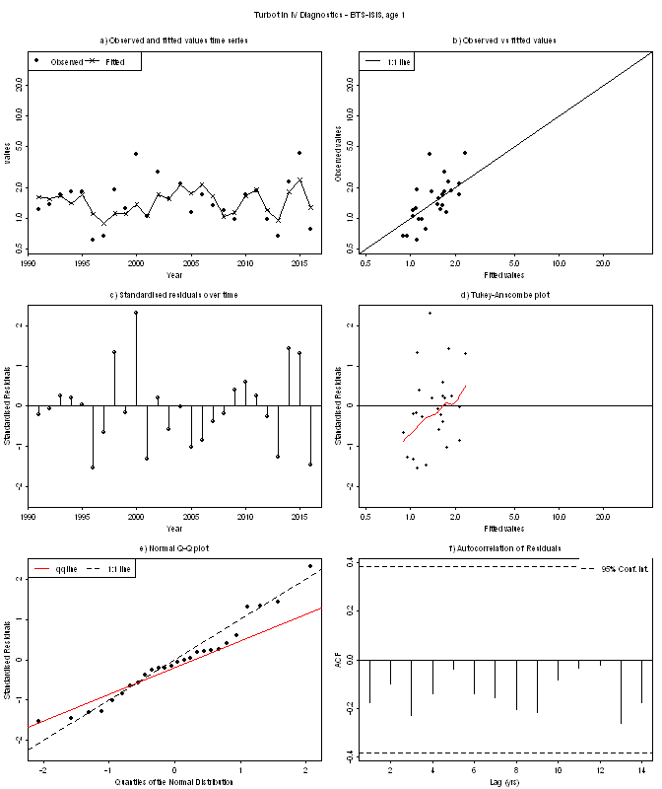

The next figure that follows is a parameter-correlation plot. It shows the correlation among all parameters that are estimated in the model. Fpar parameters refer to catchabilities, Fstates to the random walk in F, logN to the random walk in N, logObs to the observation variances, fRARdist to the auto-correlation in the surveys and trans_rho to the correlation in the F-random walks.

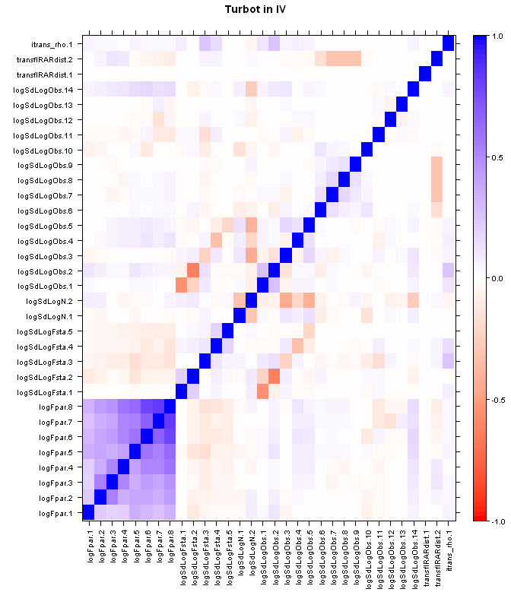

A plot showing the observation variance vs the CV of that estimate is given, ideally having low CV for all parameters.

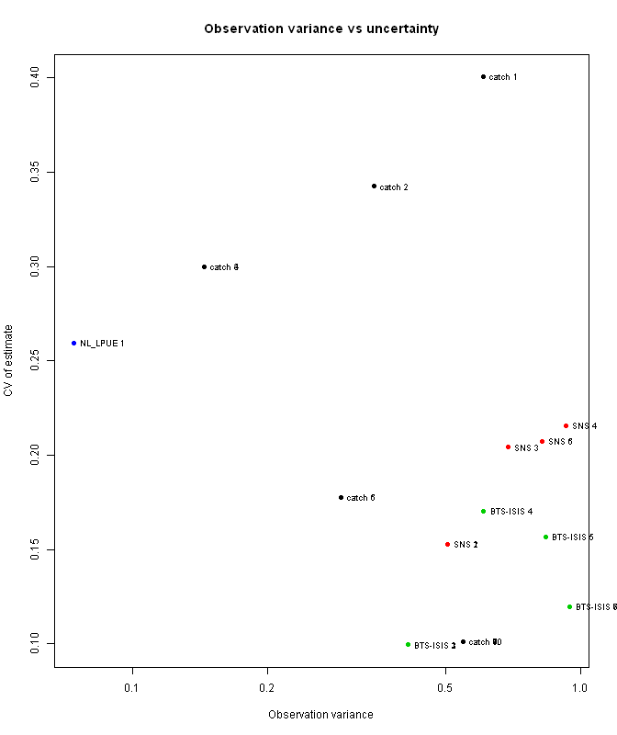

Hereafter, the catchabilities of the surveys are given for all surveys with more than 1 age-group. 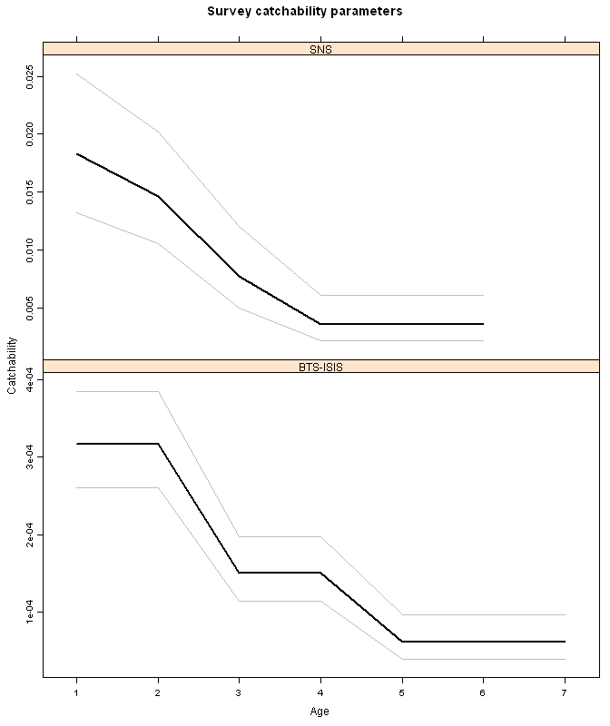

The estimated observation variances (scaling factor for each of the surveys) is given below. It is ordered from the best to the worst survey and has colour coding to show which bars belong to one dataset.

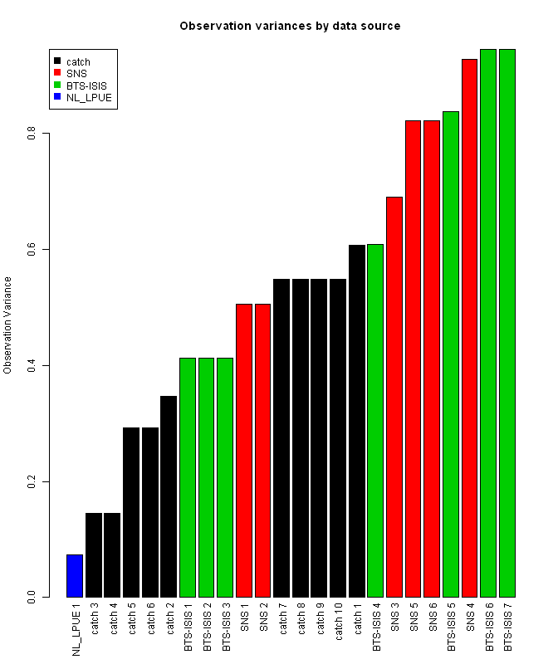

The estimated selectivity’s are given in the figure below. They are grouped by a 5-year period. Values represent actual F-at-age.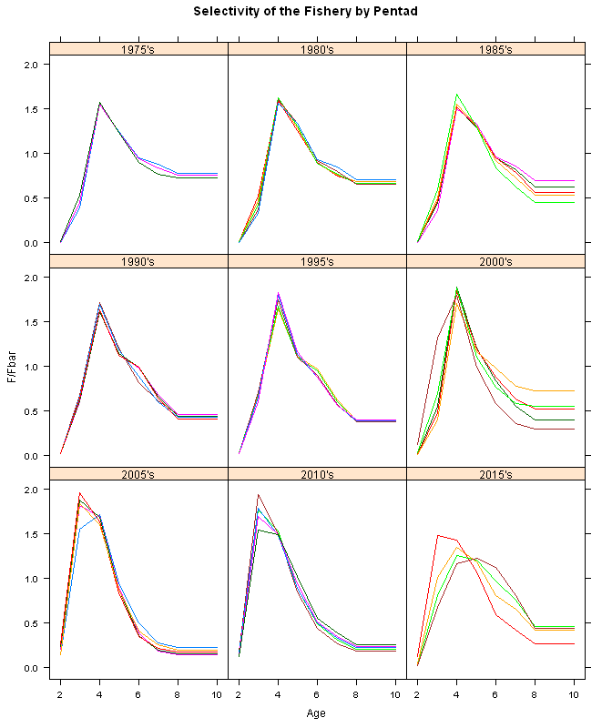

A summary plot of SSB, F and Recruitment is given below including the uncertainty bounds.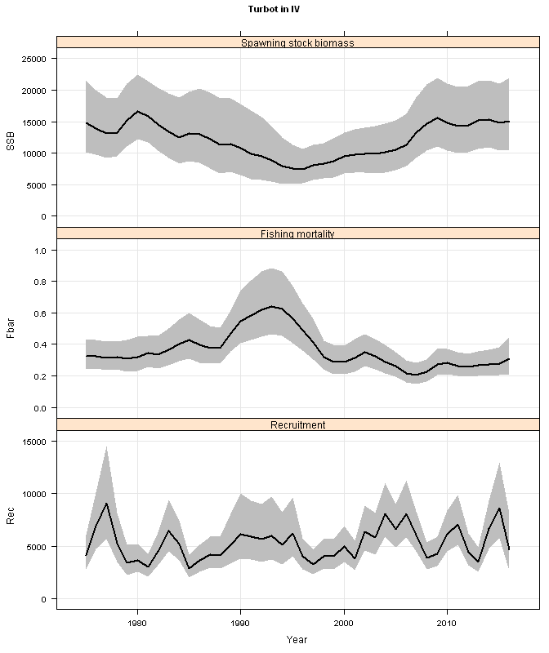

A different style of presenting residuals is the bubble plot, which also allows to detect year and cohort effects a bit better. 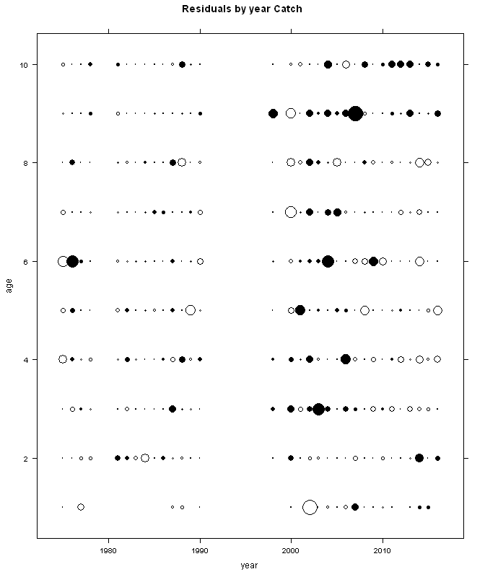

The estimated correlation between age-groups is given in the figure below. The rounder the circle, the less correlation there is. Flat lines indicate a 100% correlation

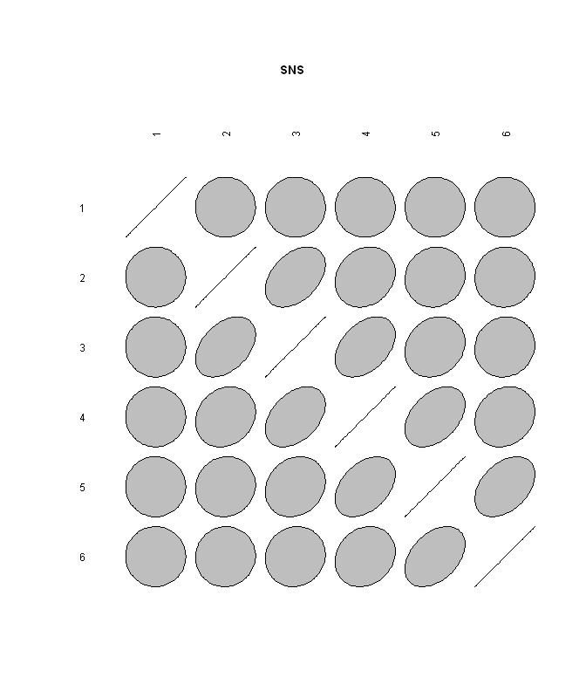

Then a number of retrospective diagnostics follow. The first is the retro-plot on SSB, F and R

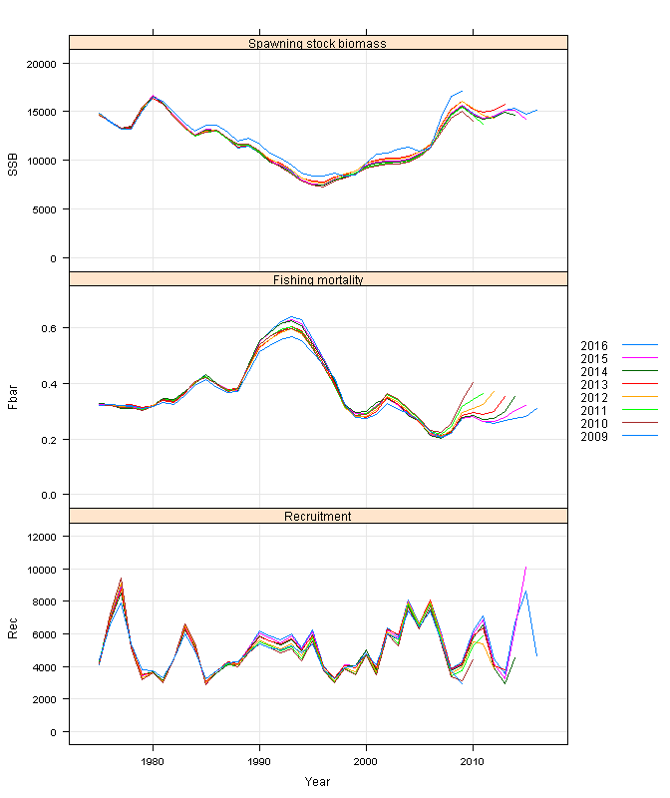

Hereafter, a retro-plot on the value of the estimated parameters is given. Ideally, all show a flat line indicating that with reducing the model with a year’s worth of data does not affect the parameters to be estimated. logSdLogN = the random walk in N, logSdLogObs is the observation variance in the surveys and catch, logFpar are the catchability parameters and logSdLogFsta are the sd’s of the random walks in F.

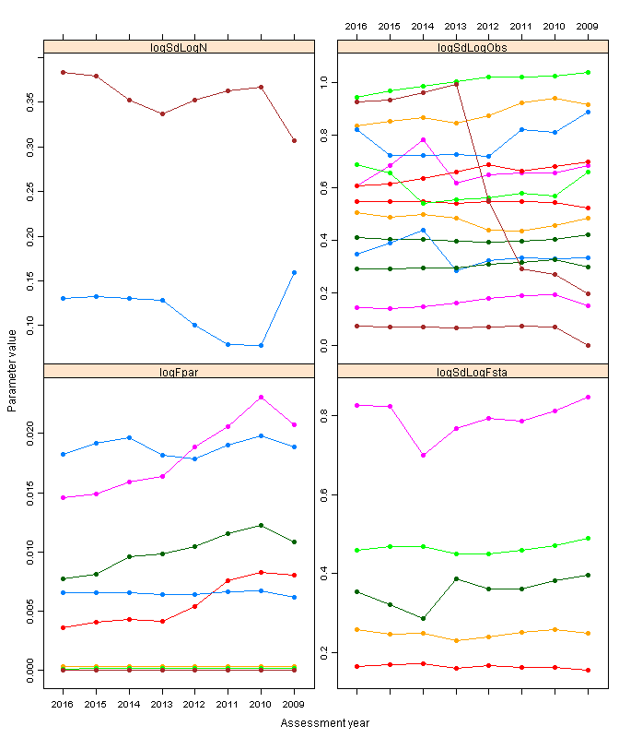

A retrospective selectivity pattern is given below.

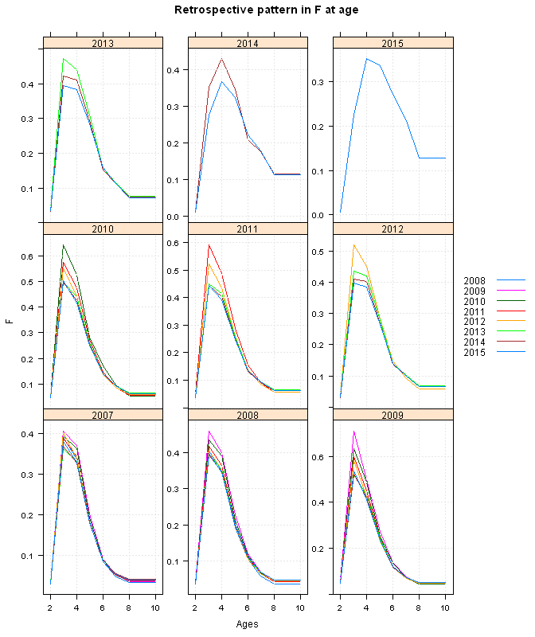

Finally, a two-panel figure showing the AIC and the mohns-rho (7-year peel) is given.

